Spain and Portugal. Holiday + Barcelona

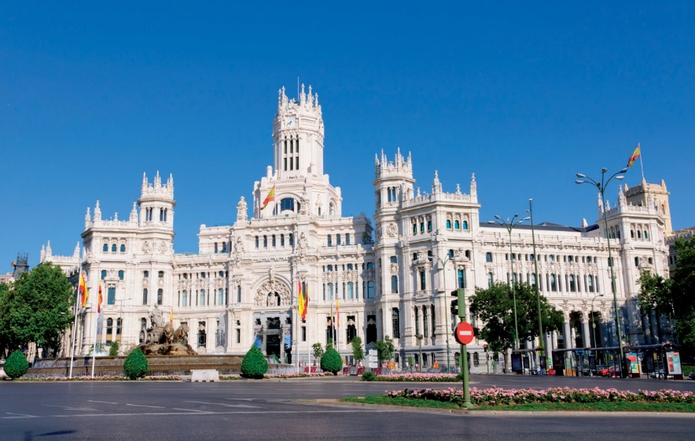

MADRID

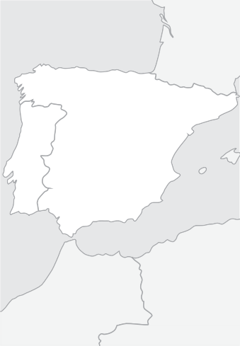

Lisbon

**PORTUGAL**

Mérida

Madrid

Fátima

Porto

Barcelona

Salamanca

**SPAIN**

Santiago

**Guaranteed Departure Tours**

**Spain & Portugal**

# From 880 €

12 days / 11 nights

Barcelona - Madrid - Segovia - Avila - Salamanca - Santiago de Compostela - Viana do Castelo - Porto - Fatima - Aveiro - Lisbon - Merida - Madrid

## Departures from Barcelona: Saturday

**2019**

|  |  |
| --- | --- |
| March | 30 |
| April | 06, 13, 20, 27 |
| May | 04, 11, 18, 25 |
| June | 01, 08, 15, 22, 29 |
| July | 06, 13, 20, 27 |
| August | 03, 10, 17, 24, 31 |
| September | 07, 14, 21, 28 |
| October | 05, 12, 19, 26 |
| November | 02, 16, 30 |
| December | 14, 28 |
| 2020 |  |
| January | 11, 25 |
| February | 08, 22 |
| March | 07, 14, 21, 28 |
| April | 04, 11, 18, 25 |

Day 1, Saturday: BARCELONA Arrival at Barcelona airport. You will be trans- ferred to your First Class hotel. It is suggested that you take advantage of the free time to get to know one of Europe’s most cosmopol- itan cities. In the evening, it is suggested to dine at the Pueblo Español, featuring architec- tural replicas from all of Spain’s regions. PACKAGE includes dinner tonight. Accommodations.

### Day 2, Sunday: BARCELONA

Buffet breakfast. This morning enjoy an es- corted tour of one of Europe’s most beautiful cities. See the ancient Gothic Quarter with its magnificent cathedral. Stop to admire the ex- terior of Gaudi’s masterwork, the Basilica of the Sacred Family (Sagrada Familia). Continue to Montjuich Hill (site of the Olympic Stadium), to enjoy a spectacular view of Barcelona and its port area. Free time for lunch on your own. Luncheon included today in PACKAGE. Afternoon free. Accommodations.

Day 3, Monday: BARCELONA - MADRID

Buffet breakfast. Departure into old Aragon and into the proud city of Zaragoza. Pause downtown in a main plaza where you will have free time to visit the impressive Basil- ica of El Pilar and have lunch on your own. Continue on to Madrid.In the early evening, enjoy an “Illuminated Madrid” drive through the bustling streets of the old city, ending at the historical and impressive Plaza Mayor. This area is home to some of the most typical restaurants and taverns, which serve the deli- cious “tapas”. PACKAGE includes a Tapas Dinner tonight. Return to your hotel at your own convenience. Accommodations.

### Day 4, Tuesday: MADRID

Buffet breakfast. This morning’s escorted sightseeing tour will allow you to get a glimpse of some of Madrid’s most outstand- ing attractions, like the Puerta del Sol, the magnificent fountains of Neptune and Ci- beles, the stately Alcala Gate, the busy Gran Via, the Plaza de España and the Plaza de Oriente.Free afternoon to explore Madrid’s famous Art Museums or perhaps take an op- tional tour to the Imperial former capital city of Toledo, where you will be escorted through its narrow cobblestone streets, soaking up the medieval atmosphere. Touring will include the interior of the magnificent Gothic cathedral and a visit to St. Tome Church, where El Greco’s masterpiece painting is displayed. Accommodations.

### Day 5, Wednesday: MADRID - SE- GOVIA - AVILA - SALAMANCA

Buffet breakfast. Departure into old Castile and the magnificent medieval city of Segovia, with its 2000 year old Roman aqueduct and impressive Alcazar Castle. Pause in Avila to admire the perfectly preserved 11th century city walls before continuing to the charming old university city of Salamanca. Afternoon city tour. PACKAGE includes a dinner. Tonight a walk through the beautiful main plaza, always lively with activity, is rec- ommended. Accommodations

### Day 6, Thursday: SALAMANCA - SANTIAGO DE COMPOSTELA

Buffet breakfast. Departure toward the North of Spain, entering in Galicia. Arrival to the beautiful city of Santiago de Compostela. In the afternoon guided tour of the old city of Santiago de Compostela and its beautiful Cathedral Tonight we can have in the Hotel a nice dinner. PACKAGE includes dinner. Accommodations.

### Day 7, Friday: SANTIAGO - VIANA DO CASTELO - PORTO

Breakfast buffet. Departure to Rias Baixas to continue our journey to Portugal. Visit the town of Viana do Castelo, in the mouth of the Lima River with its historic center and castle. Con- tinue to Porto, capital of northern Portugal in the Douro region. Accommodation.

### Day 8, Saturday: PORTO

Buffet breakfast. local guided city visiting one local winery. PACKAGE includes a typical lunch. Afternoon free. Accommodations.

### Day 9, Sunday: PORTO - AVEIRO - FATIMA - LISBON

Buffet breakfast and departure to Aveiro, the “city of canals” and known as the Venice of Portugal. Continue to Fatima one of the pil- grimage centers of Christianity. Free time to visit the basilica and lunch (Lunch included in PACKAGE) Continue to Lisbon. Tonight enjoy an optional opportunity to lis- ten to the hauntingly beautiful Fado music while enjoying a delicious dinner. PREMIUM PACKAGE includes Fado show and dinner. Accommodations.

### Day 10, Monday: LISBON

Buffet breakfast. Morning tour of this ancient and lovely city overlooking the Tagus River. Admire its splendid avenues and monuments like the Tower of Belem and the Jeronimos Monastery. Afternoon free, with a strong rec- ommendation to visit the charming villages of Sintra and Cascais (this tour included in PACKAGE). Accommodations.

### Day 11, Tuesday: LISBON - ME- RIDA - MADRID

Buffet breakfast. Departure toward the Span- ish border, and pause in Merida to admire the impressive Roman Amphitheatre archeo- logical site. Lunch is included in PACKAGE. Continue to Madrid for late after- noon arrival.

Day 12, Wednesday: MADRID Buffet breakfast and transfer at the appropriate time to Madrid airport.

#### TOUR FEATURES

|  |  |
| --- | --- |
| HOTELS USED  or similar | |
| Category Confort Hotels | |
| Barcelona  Madrid  Salamanca Santiago Porto Lisbon Madrid | Rafael Badalona / Exe barbera  Barcelona Gate  Praga / Holiday Inn Piramides Muralto / Chamartin  G.H. Corona Sol  Los Abetos G.H. / Tryp Santiago Park Hotel Gaia / Ibis Gaia  Exe Liberdade / Vip Zurique Praga /Holiday Inn Piramides Muralto / Chamartin |
| Category Superior Hotels | |
| Barcelona AC Som / Alimara / Porta Fira  Madrid Praga / Holiday Inn Piramides  Muralto / Chamartin  Salamanca G.H. Corona Sol  Santiago Nh Collection / Hesperia Vigo  Porto Novotel Porto Gaia  Lisbon Marriott / Acores / Real Palacio  Madrid Praga /Holiday Inn Piramides  Muralto / Chamartin  THE NIGT OF MAY 10, 17, 24, 31, JUNE 7 & 14, 2019 WILL BE REALIZED IN VIGO AND NOT IN SANTIAGO | |

Price per Person in Euros In Double / Twin room

Tour 12 days: Barcelona / Madrid

CATEGORY CONFORT HOTELS:

April 1 - 8, 2019 1.150

April 13 / June 22 955

June 28 / August 16 940

August 24 / October 18 955

October 26 / March 21, 2020 880

March 27, 2020 / April 25, 2020 1.020

Supl. Single Room Apr 1/Oct 31, 2019 + Apr 2020 480

Supl. Single Room Nov 1, 2019 / Mar 31, 2020 445

CATEGORY SUPERIOR HOTELS:

April 1 - 8, 2019 1.230

April 13 / June 22 1.100

June 28 / August 16 1.050

August 24 / October 18 1.100

October 26 / March 21, 2020 985

March 27, 2020 / April 25, 2020 1.175

Supl. Single Room Apr 1/Oct 31, 2019 + Apr 2020 610

Supl. Single Room Nov 1, 2019 / Mar 31, 2020 535

P Transfers airport-hotel-airport

P Accommodations in hotels of Category Confort or Superior

P Bountiful buffet breakfast daily

P Deluxe air-conditioned motorcoach transportation

P Professional tour escort throughout (bilingual English/Spanish)

P Escorted sightseeing tours with bilingual guide in Barcelona, Madrid, Salamanca, Porto, and Lisbon

P Evening Illuminations tour of Madrid

P Travel bag

#### OPTIONAL PACKAGE INCLUDES

12 DAYS: BARCELONA / MADRID: **240 €** · INCLUDES 9 MEALS AND 3 EXTRAS

P Entrance & dinner at Spanish Village of Barcelona

P Typical lunch in the Olympic Port of Barcelona

P “Tapas” dinner in Madrid

P Dinner in Salamanca

P Dinner in Santiago

P Lunch in Porto

P Lunch in Fatima

P Dinner and Fados Show in Lisbon

P Tour of Sintra and Cascais

P Lunch in Merida